6.1
Question:

Solution:
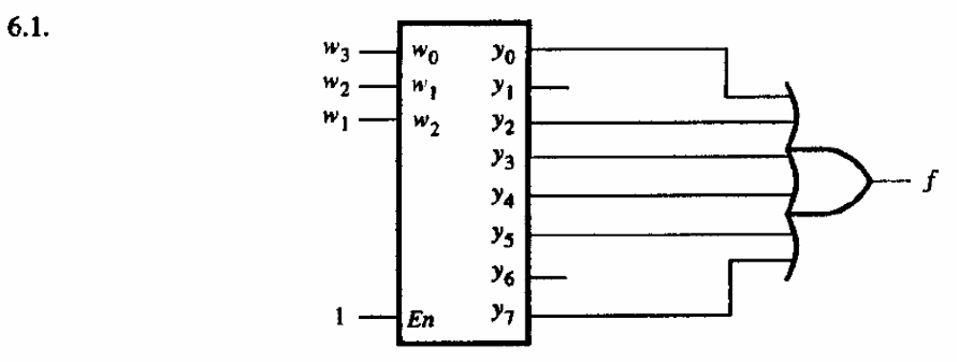

6.5
Question:

Solution:
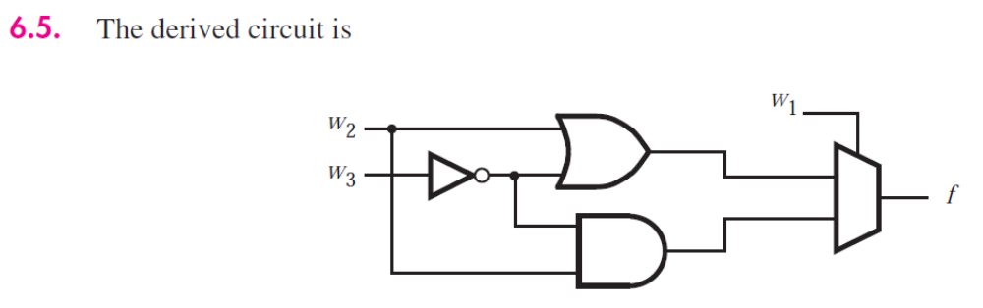

6.7
Question:

Solution:
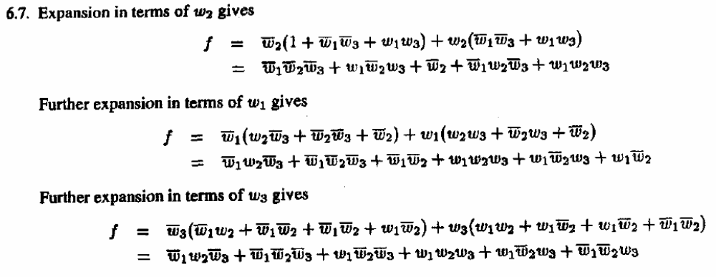

6.11
Question:

Solution:
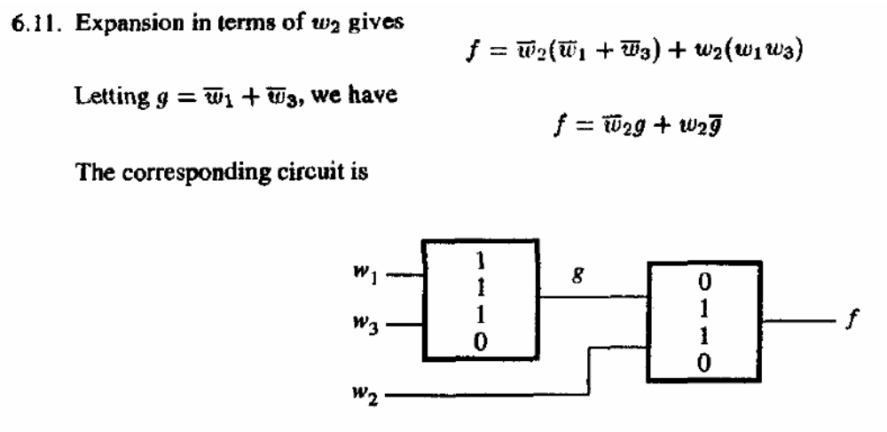

6.12
Question:

Solution:
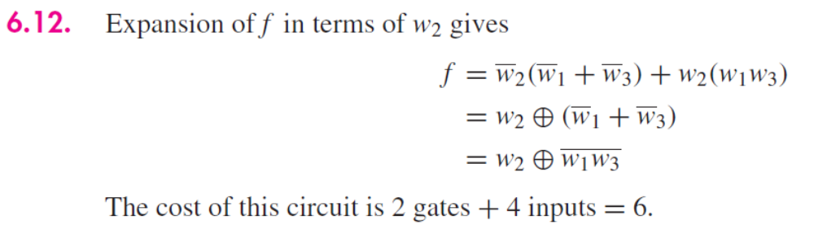

6.18
Question:
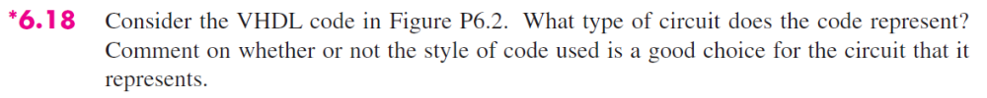
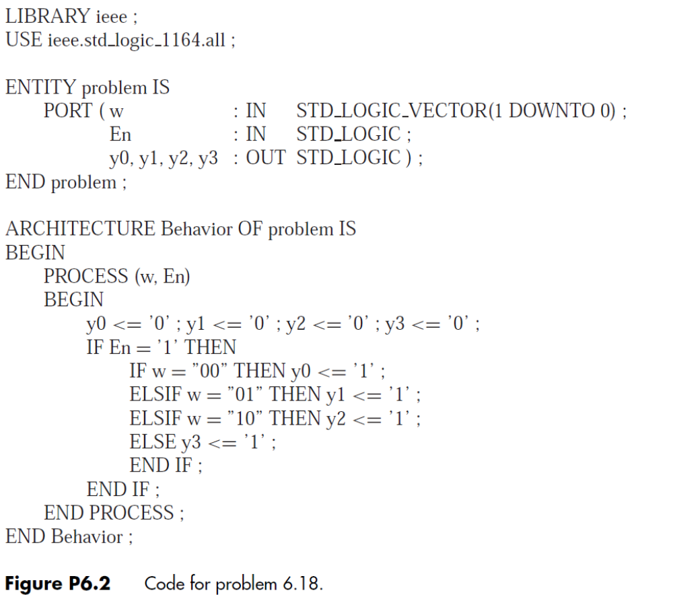

Solution:

6.19
Questions:
a. just write the selected signal assignment statement
b. using a conditional assignment statement
Describe the situations when you would use a selected signal assignment statement in VHDL. When would you use a conditional assignment statement instead?

Solution:
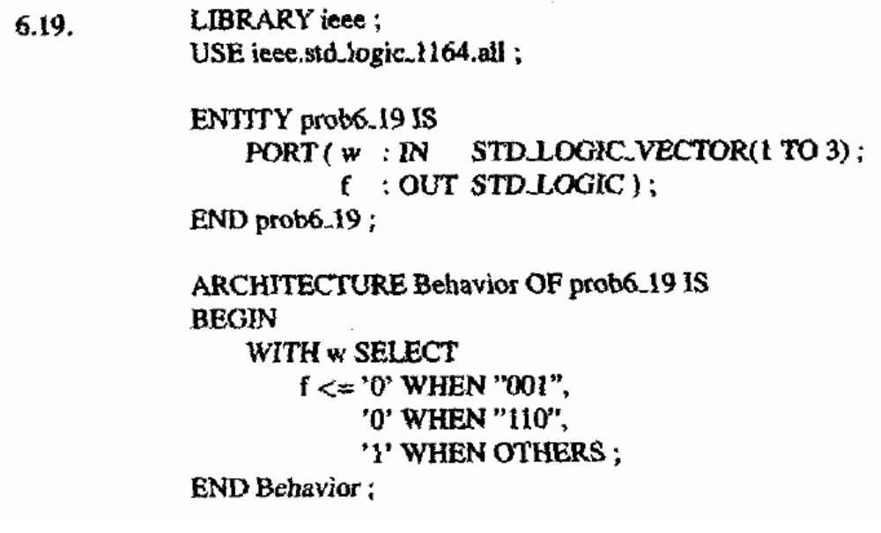

6.26 - you may use the code from 6.18
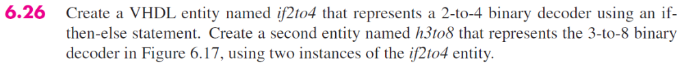

Solution:
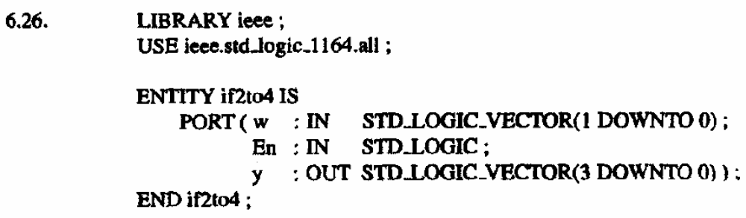
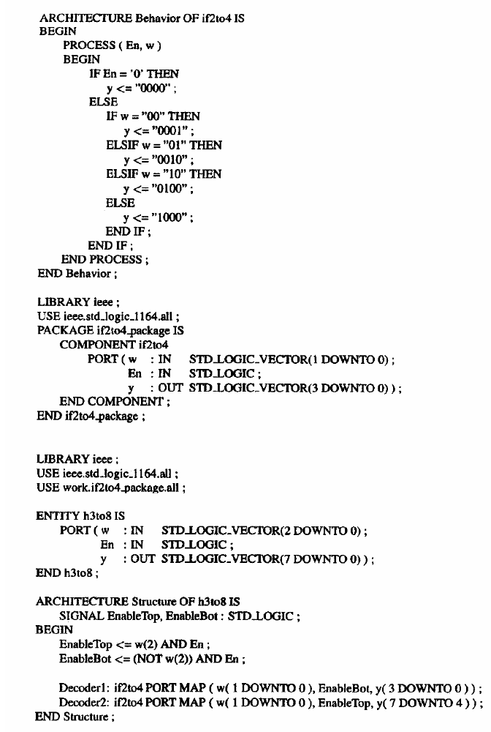
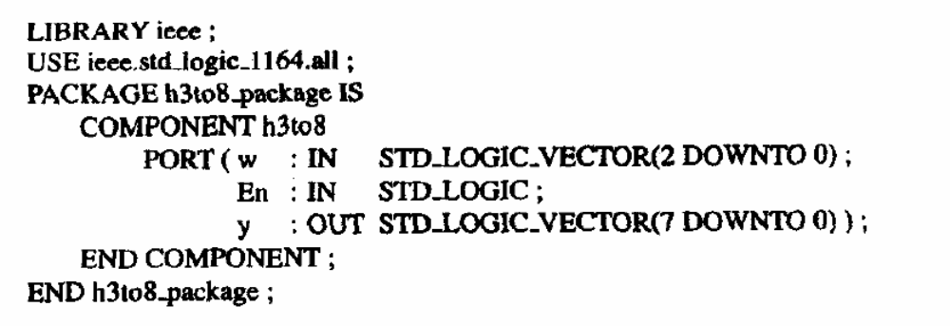

6.31
Question:
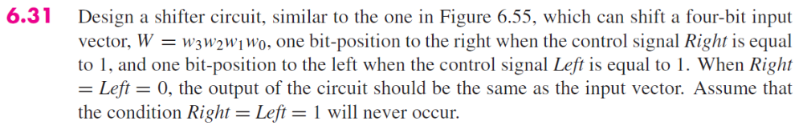

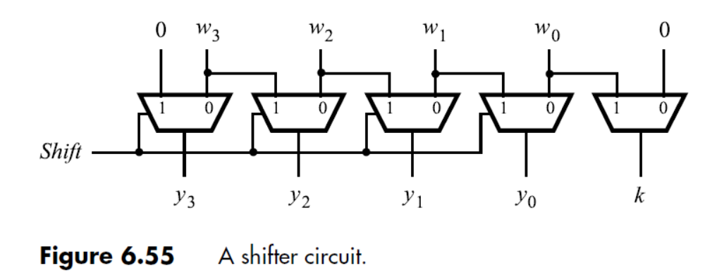

Solution:
